Before initial parsing, simple html page with some ad

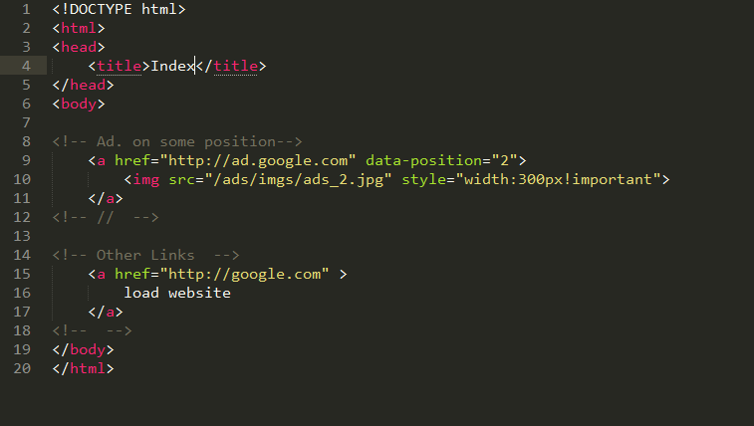

Applying initial parsing

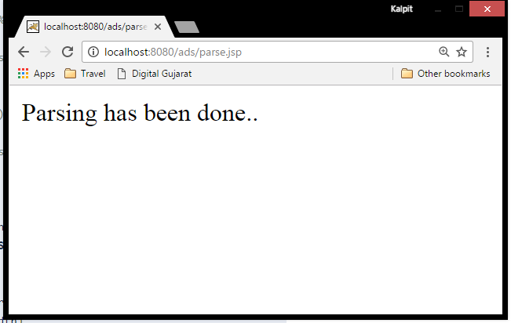

After Parsing static links have been updated to dynamic links inside iframe.

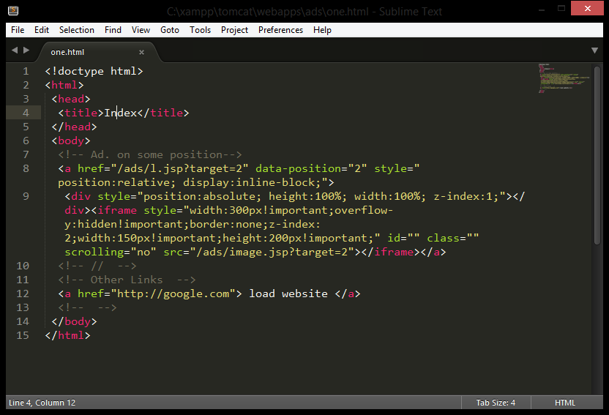

Before Dynamic links

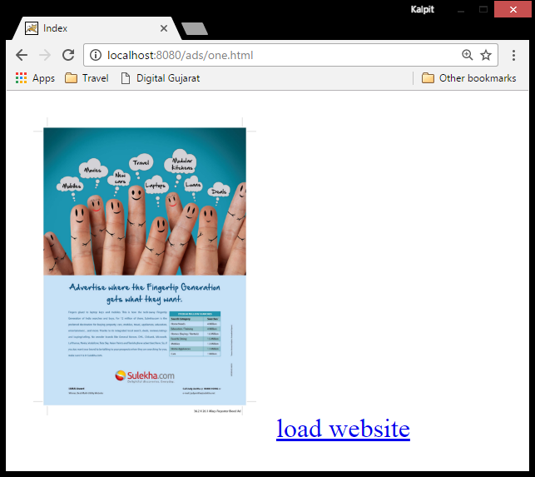

After link updates, (Design will be still same)



Cron fired on perticular interval

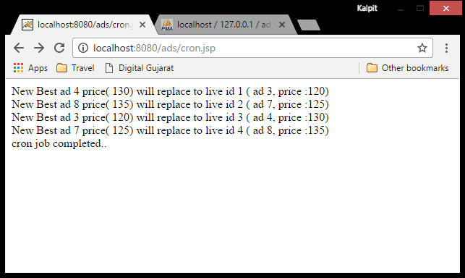

Ad had clicks less then threshould so it has been updated after cron fiired

